***Candytown***

***Vintage Trials***

***2650 Steinruck Road, Elizabethtown, PA***

[***www.candytownmc.org***](http://www.candytownmc.org)

#### *Sunday* April 6th, 2025

#### Event start time 12:00 noon

*Sign-up: 10:00am - 12:00pm*

*$10 per Vintage rider - $20.00 per Modern rider*

*$5.00 per person gate fee*

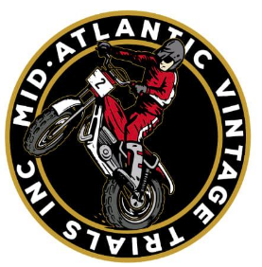

**Restrooms ~ Primitive Camping Saturday ~ Concession Stand**

**No Stop Rules – Helmets Required – AMA Membership Not Required**

**No Spectator Motorcycle or ATV Riding Allowed**

Club address is: 2650 Steinruck Road, Elizabethtown, PA

GPS coordinates: 40012’55.34”N 76039’52.1”W 719’ ELEV

See [www.candytownmc.org](http://www.candytownmc.org) for additional Information

Or email Mike Womer: mikef500@gmail.com



***Sanctioned by:***

***Mid-Atlantic Vintage Trials***

***Point classes for Vintage and Modern Bikes***